BOARD OF TRUST & MANAGEMENT COMMITTEE

SL NO | PHOTO | NAMES , ADDRESS, | DESIGNATION | QUALIFICATION | OCCUPATION | AGE | SIGNATURE
1 | 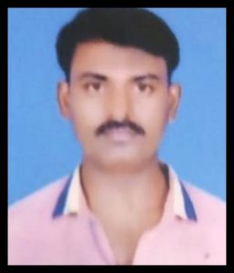 | Sri, Kumar Naik S  S/O Late: Shiva Naik B  #31,9th main, Anchepalya Srikantapura  Prakruthi Badavane Bangalore -5660073 | President | SSLC | Own business  (Contractor) | 45
2 | 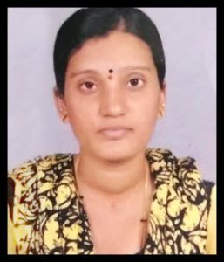 | Pavithra B L  W/o Ramesh Naik S  NO.35,2nd Main Road 5th cross, jnanabharathi 4th block,nagadevana halli near annapoorneshwari temple 560056 | Secretary | PUC | private ngo | 37
3 | 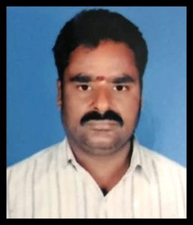 | N Murugesan S/o Nagayan  NO -3,3rd Cross, 3rd Block,  8th Main, Hbr Layout,  Bangalore – 560043 | Treasurer | 7TH Std | Own business  ( contractor) | 55
4 | 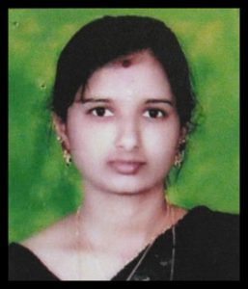 | Smt Yashodha.V W/O Late Venkatesh  #1163,9th Main,11th Cross,  Mahalakshmipuram  Bangalore-560086 | Trustee | PUC | BBMP  (Contract work) | 40
5 | 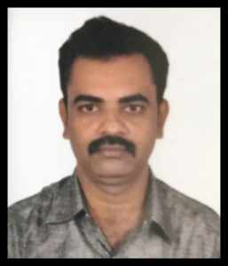 | Sri Nagaraj P S/O Pullaiah  #102,Holebenavalli Village,  Shivamogga Taluk & Ditrict  577222 | Trustee | SSLC | Own business  ( Boutique) | 44

